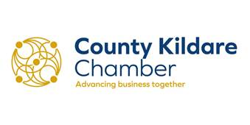

ANNUAL GENERAL MEETING

Notice is hereby given that the 2021 Annual General Meeting of County Kildare Chamber will be held on Monday 11th October 2021 at 6pm. The meeting will be a virtual meeting using the Zoom Platform (a link to the meeting will be forwarded by separate email to all members who register to attend)
for the purpose of transacting the following business:

AGENDA

- To confirm that the meeting is properly convened.

- To note roll-call of those attending and any apologies received.

- To approve the minutes of the 2020 Annual General Meeting.

- To receive and consider the Directors’ and Auditors’ Reports and Financial Statements for the year ended 31st December 2020.

- To elect the President, Vice President, Secretary, Treasurer and the board of the Chamber for the 2021/2012 term.

- To re-appoint Kealy Mehigan Chartered Accountants and Auditors as auditors of the Company.

- AOB.

Dated this: 20th September 2021
By Order of the Board

Ronan Twohig
Chamber Secretary

