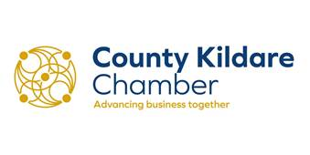
Fingal County Council
via website
Date: 9th February 2022
Dear Sir/Madam,
RE: Draft Regulatory Decision- Dublin Airport
1.0 INTRODUCTION
County Kildare Chamber is the business organisation in Kildare, proactively working to identify and progress developments that are facilitative of economic and sustainable growth. Representing an employer base of 400 businesses and over 38,000 employees across the county, County Kildare Chamber is the largest business organisation in the mid-east region of Ireland.
Given the significant breadth and depth of our membership, and our representation on various bodies at local and national level, County Kildare Chamber constitutes the representative voice for business in Kildare, a particularly important role given the current economic circumstances in the county and the state.
2.0 SUBMISSION
County Kildare Chamber notes the Airport Noise Competent Authority (ANCA) draft decision in relation to Dublin Airport North Runway, particularly the use of a noise quota system and allowing the use of North Runway for the night shoulder hours 2300 to midnight and 0600 to 0700.
In our original submission to Fingal County Council, County Kildare Chamber outlined how condition 3 and condition 5 would have had a detrimental impact on the business community. Early morning flights are the most popular slots of the day in Dublin Airport and those conditions would have reduced the potential for same day return. Thus reducing the number of business travellers considerably, whilst increasing costs (due to overnight accommodation etc.) for those that do. We welcome the replacement of these two restrictive conditions given the negative impact they would have on tourism, trade and FDI in Ireland.

This Draft Decision has balanced the requirement for operational flexibility at Dublin Airport. The business community has been damaged by the double impacts of Covid-19 and Brexit. These crises will continue to hurt our economy into the coming years. Dublin Airports role in connecting Ireland to the world will be even more important while we are trying to stimulate growth in our domestic economy by diversifying our trading partners. County Kildare Chamber feels this decision has taken on board the interests of the key stakeholders, whilst also taking into considerations the community concerns regarding noise particularly.
The new connections that the North Runway will make possible will be key to creating new opportunities for Irish businesses. These opportunities will be even more important given the kind of Brexit agreement that has been agreed to, and the challenges that it deal presents when supply from, and selling to, Britain.
County Kildare Chamber represents a large cohort of businesses who utilise Dublin Airport on a daily basis. Our Multi Nationals, large indigenous SME’s and our tourism/hospitality members all benefit from having Dublin International Airport on its doorstep.
The current restrictions on late arrivals and early departures that these conditions will result in increases the costs for the client airlines that wish to use Dublin Airport as their planes will need to spend less time in the air and more time on the ground.
As we all look forward to a new world post Covid, the need to have an International Airport that is competitive is essential. The positive economic impact for the region will be immense. The North Runway is critical to Ireland and to the business community in Kildare and the Mid East Region

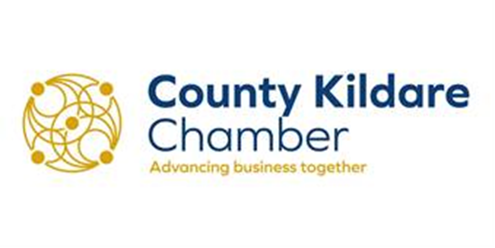

3.0 CONCLUSION
We trust that the contents of this submission will be taken into consideration by the Airport Noise Competent Authority. Please do not hesitate to contact us if you have any queries regarding this submission.
Yours faithfully,
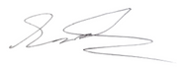
Sinéad Ronan
Public Affairs Manager
County Kildare Chamber
www.countykildarechamber.ie
045 894074

